**Superstore Sales Dashboard Analysis**

Student’s Name

Institutional Affiliation

Course Number and Name

Instructor Name

Due Date

**Superstore Sales Dashboard Analysis**

1. **Sales Chart**

**The Highest Selling Category (Furniture, Office Supplies, or Technology) of products in 2015, 2016, & 2017**

1. **2015**

In 2015, the Office Supplies category in the West region of the United States had the highest selling of products, that is, 50,800. Most startup companies are setting up new offices in the West region, particularly in Silicon Valley, California.

1. **2016**

In 2016, the Technology category in the East region of the United States recorded the highest sales of products, that is, 61,976. This is because the East region is also quickly catching up with the West region regarding technological innovations, hence the high purchase of products from the technology category.

1. **2017**

In 2017, the Furniture category in the West region of the United States recorded the highest sales of products, that is, 73,736. Most tech companies were established in that region, hence high migration rates. CEO relocated there to set up new offices. Also, unemployed people moved there to seek employment. Therefore, all these factors strongly contribute to the high sales of products from the furniture category as people require new furniture upon relocation.

1. **Category, Region, and Year that Suffered a Loss**

|  |  |  |  |
| --- | --- | --- | --- |
| Category | Region | Year | Loss ($) |
| Furniture | Central | 2015 | 1050 |
| Furniture | Central | 2016 | 296 |
| Furniture | Central | 2017 | 328 |
| Furniture | Central | 2018 | 1178 |
| Furniture | Central | 2019 | 19 |
| Furniture | East | 2015 | 740 |
| Furniture | South | 2018 | 1063 |

The following inferences can be made from the above table:

1. Furniture is the only category that recorded or somewhat suffered losses.
2. Central region is the most affected region, suffering losses for five consecutive years (2015 - 2019).
3. The highest losses ($ 1063) were recorded from Furniture sales in the South region of the United States of America in 2018.
4. The lowest losses ($ 19) were recorded from Furniture sales in the United States of America's Central region in 2019.
5. **Superstore Sales Number from All Categories**

|  |  |  |  |  |  |  |  |  |
| --- | --- | --- | --- | --- | --- | --- | --- | --- |
| Consumer | | | Corporate | | | Home Office | | |
| Furniture | Office Supplies | Technology | Furniture | Office Supplies | Technology | Furniture | Office Supplies | Technology |
| 391,049 | 363,952 | 406,400 | 229,020 | 230,676 | 246,450 | 121,931 | 124,418 | 183,304 |

The above figures represent the number of sales made per each category in a given segment. The above data contain three segments, i.e. Consumer, Corporate and Home Office. Each segment has three categories of products. They include Furniture, Office Supplies, and Technology. In all segments, the technology category recorded the highest number of sales simply because the world is advancing technologically; hence, most individuals want to participate in providing digital solutions to the world's problems. On the other hand, the furniture category recorded the lowest number of sales in both the Corporate and Home Office segments, probably because furniture products have long-lasting and durable characteristics; hence, once purchased, it takes longer to replace them.

1. **Three Largest Bubbles**

|  |  |  |  |
| --- | --- | --- | --- |
| Largest Bubbles (Sub-category) | Profit | Sales | Percentage of Profit  (Profit/Sales) (%) |
| Binders | 30,222 | 203,413 | 14.86 |
| Paper | 34,054 | 78,478 | 43.39 |
| Furnishings | 13,059 | 91,705 | 14.24 |

1. **The Five Highest States and Their Sales Amounts**

|  |  |
| --- | --- |
| States | Sales Amounts ($) |
| 1. California | 457,688 |
| 1. New York | 310,876 |
| 1. Texas | 170,188 |
| 1. Washington | 138,641 |
| 1. Pennsylvania | 116,512 |

From the above table, the following observations can be made;

1. California recorded the highest sales amounts i.e. $ 457,688
2. New York was the second, followed by Texas, Washington, and Pennsylvania.
3. **Three Lowest Sub-Categories and Their Sales Numbers**

|  |  |
| --- | --- |
| Sub-Categories | Sales Numbers |
| Fasteners | 3,024 |
| Labels | 12,486 |
| Envelopes | 16,476 |

The above sub-categories, i.e. fasteners, labels, and envelopes, are considered ancient physical items whose applications are limited in the modern world. Many companies and individuals are shifting towards digital documentation and communication. For instance, DocuSign, email, and electronic documents could minimize or replace the physical labels and envelopes. Replacement of these physical items is also suitable for the environment as pollution and waste are reduced.

1. **Technology Numbers in Consumer and Corporate for 2015-2018**

|  |  |  |
| --- | --- | --- |
| Technology | Year | Sales Number |
| 1. Consumer | 2015 | 95,117 |
|  | 2016 | 90,045 |
|  | 2017 | 112,768 |
|  | 2018 | 108,061 |
| 1. Corporate | 2015 | 32,010 |
|  | 2016 | 50,208 |
|  | 2017 | 75,272 |
|  | 2018 | 88,961 |

The following inferences can be made from the above table;

1. The technology numbers in the Consumer segment form a cyclical pattern: an increase and decrease of sales numbers over the period (2015 - 2018) due to factors such as market dynamics and product life cycles.
2. There was a general uptrend in the technology numbers in Corporate between 2015 and 2018, probably because of the high demand for digital solutions and rapid technological advancements (Jin et al., 2023).
3. **The Value of a Data Dashboard in an Organization**

The importance of a data dashboard in an organization ought to be emphasized in today's data-driven decision-making world. A data dashboard visualizes key performance indicators (KPIs), for instance, profits and sales, and essential metrics, offering an instantaneous view of the organization's performance across sectors and operations. This visual clarity allows executives, supervisors, and staff to quickly seize complicated statistics and trends, facilitating better-informed and rapid decision-making processes (Sarikaya et al., 2018).

A data dashboard's capacity to integrate different data sources into a uniform structure is one of its key benefits (Vila et al., 2018). This consolidation enables an integrated view of company performance by dismantling data silos and boosting cross-functional communication. Decision-makers can quickly detect patterns, trends, and outliers, allowing them to respond to new possibilities or difficulties.

Additionally, a well-designed data dashboard improves organizational transparency (Chokki et al., 2022). When workers across all ranks access timely and accurate information, a culture of accountability is fostered, and employees are empowered to connect their efforts with overall strategic goals. This transparency also improves communication by allowing teams to actively participate in data-driven conversations and work jointly toward common goals.

Furthermore, since the data dashboards are real-time, organizations' policymakers can use the most up-to-date information. This responsiveness is crucial in a fast-changing business setting where swift, data-driven decisions may make the difference between success and failure. Finally, besides data presentation being one of the values of a data dashboard, the other value is the ability of a dashboard to transform unprocessed data into actionable insights that drive organizational performance and offer resilience in a volatile market environment.

**References**

Chokki, A. P., Simonofski, A., Frénay, B., & Vanderose, B. (2022). Engaging Citizens with Open Government Data: The Value of Dashboards Compared to Individual Visualizations. *Digital Government: Research and Practice*, *3*(3), 1-20.

Jin, C., Xu, A., Zhu, Y., & Li, J. (2023). Technology growth in the digital age: Evidence from China. *Technological Forecasting and Social Change*, *187*, 122221.

Sarikaya, A., Correll, M., Bartram, L., Tory, M., & Fisher, D. (2018). What do we talk about when we talk about dashboards? *IEEE transactions on visualization and computer graphics*, *25*(1), 682-692.

Vila, R. A., Estevez, E., & Fillottrani, P. R. (2018, April). The design and use of dashboards for driving decision-making in the public sector. In *Proceedings of the 11th International Conference on Theory and Practice of Electronic Governance* (pp. 382-388).

**Appendices**

**Relationships created by the Superstore Sheets**

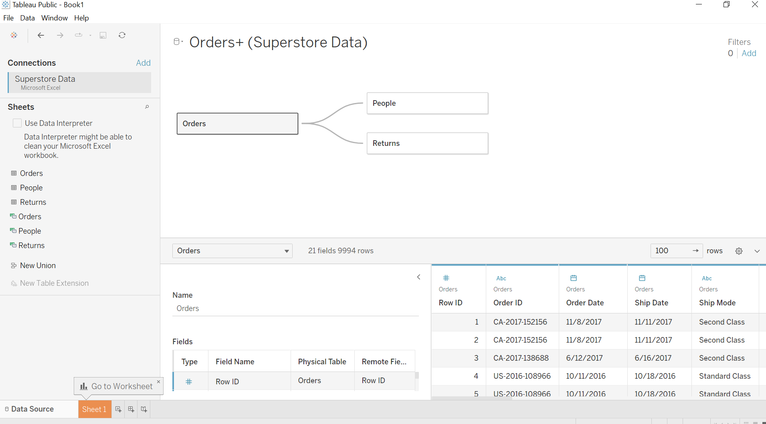

**Superstore Sales**

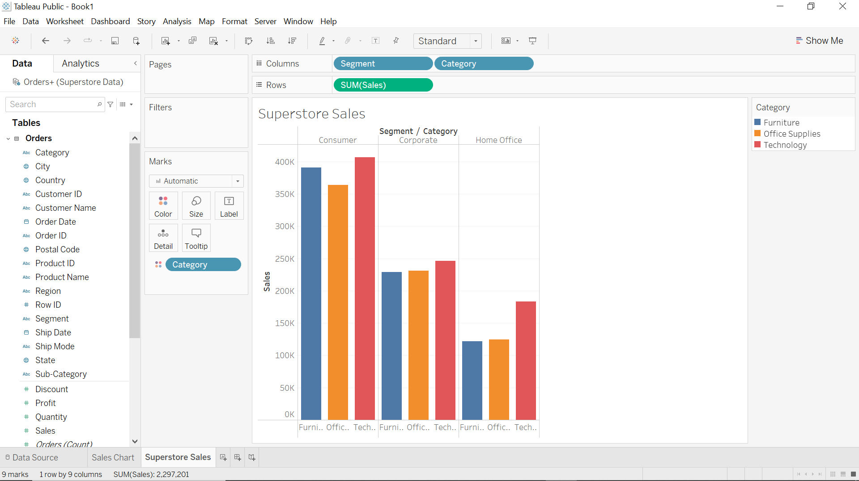

**Bubble Chart**

